Fabulous training

«Models of Human Motivation»

September 26-27, 2009, Kiev

What motivates human behavior? How do people set goals? Why do they differ from the goals of other people in similar conditions? With some people we can communicate easily while others do not understand us. Why is it so?

Motives – are the concealed, secret strings that control our actions. We can learn to recognize some of them or even take control of them. Some of them are a puzzle for us even being on the surface – we anticipate that other people are much alike us and think the same way we do.

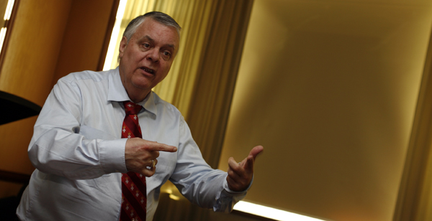

In fact, each person can become more effective by learning to recognize the main motive of other people. These skills are necessary for developing flexibility, for being able to be successful in both career and private life. Besides, understanding human motivation helps manage employees successfully, understand reasons of conflicts, set tasks so that your subordinates fulfilled them with excitement, find common language with colleagues and director.

Main tasks of the training:

- Studying the structure of three main human motivations and describing their models
- Training inner motivation to increase cooperation flexibility in business
- Learning how to develop motivation in other people so that your employees could motivate themselves and could fill excited about their work
- Learning how to translate information from one motive language into another for your employees to be able to use different motives in different projects for ultimate productivity
- Studying models and cogitative processes of high-efficient people on the example of each of three main motives to get more influence in your private life and business.

During the training participants will learn the bottom line of one of the most interesting researches of ХХ century – studying models of human motivation. We shall find out what was the key to success of our outstanding contemporaries, we shall learn their main motives and way of thinking. The training material is based on practice and many leaders of greatest companies in the world prove its efficiency.

The task of the training is to increase professional leadership efficiency on three driving motives in business.

Trainer Frank Pucelik
 | World-known business-trainer ranked among TOP-100 business-trainers of the USA (according to Organizational Development Institute of the USA), one of the three founders of NLP, the author of a number of books in psychology and dozens of articles on personnel management, motivation and information processing. Professor of Personal relationships (postgraduate department, Oklahoma University, Norman, Oklahoma, USA 1983-87)  Each year Frank Pucelik teaches more than 2 000 top managers of the most successful companies in the Ukraine, Russia, Byelorussia, Latvia. Frank Pucelik supports five rehabilitation centers for drug addicts. He is a permanent participant of different conferences, exhibitions, forums and other educational events in the Ukraine.  In the CIS countries his clients are: LukOil Volga, Cargill, Nemiroff, Coca-Cola, GlaxoSmithKline, Oracle, Saatchi&Saatchi, Kharkov Biscuit factory, Stara Fortetsja, Sandora, Alef-Vinal, Olimp, Ideal, Fozzy, Rorus, Eltrans Plus, Constanta, Raiffeisen Bank Aval, Universal bank, insurance company "Universalnaya", Galneftegaz, Morshinskaya, Castrol, Evroset, Swiss transport and shipping company AsstrA Associated Traffic AG and many other companies.

To register for the training please contact our office:

- Phone/fax: +38 (0482) 340335, 332182
- E-mail: office@frankpucelik.com

