«Negotiations: managing results»

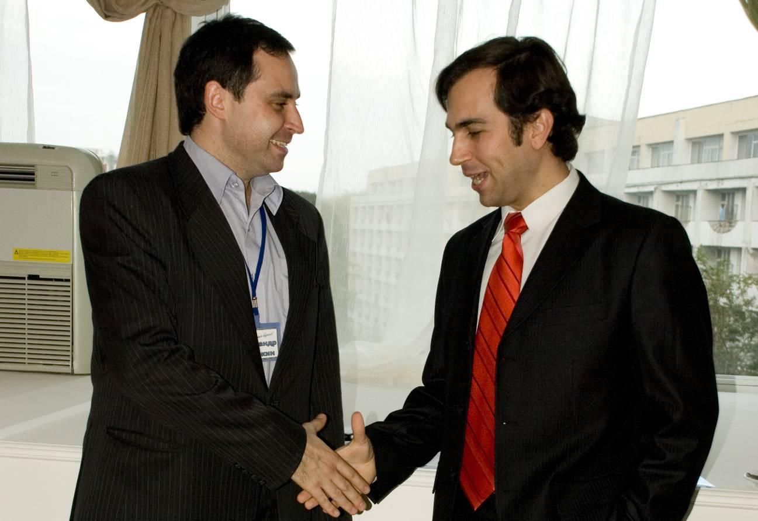

If someone does not negotiate - he already loses money. If you are not ready to negotiate - you lose at least 10 percent of each contract signed by you.

Frank Pucelik –
President of Pucelik Consulting Group
What is this training about?
Negotiation is one of the keys to success of a company on the market. How to prove that your product is best choice for your contractor? How to get the best conditions for the price that suits you? How to obtain the most suitable conditions in the course of negotiations? Negotiators must be able to debate, use different techniques and practices in order to obtain the greatest benefit, affecting the logic and emotions of partner.

The purpose and objectives of the training:
Study the methods of preparation to negotiations. Learn to define strong and weak sides of opponent. Perfect the strategy and tactics of negotiations. Learn how to respond flexibly to the different styles of communication in the negotiations and be able to select the key points in dialogue. Develop resistance to harsh techniques used against you in negotiations.

Actuality of the training:
On today market, crowded by various products, it is not enough to simply produce products or services. It is not enough even to correspond to needs of your clients. It is also necessary to know how to prove the client that your product or service is the best in this price category. This is what most successful and profitable companies see as main competitive advantage.

During the training participants will learn

Prepare for the upcoming negotiations:
• determine your own strategy of negotiations
• select appropriate tactical moves
• effectively prepare to use counter-tactics
• consolidate your positions before negotiations
• consistently use the tactic of concessions and deadlocks
Negotiations:
• quickly and exactly identify communication model of the partner
• identify the most important points in the negotiations
• use verbal and nonverbal dialogues
• conduct opponent by the desired "route" of negotiations
• stay calm and effectively respond to harsh tactics of opponents
• maintain multistage and group negotiations

Shortly about the trainer
 | Frank Pucelik - President, Chief Consultant on Organizational Development and the leading business-trainer of Pucelik Consulting Group.  World-known business-trainer on the list of Top-100 US business-trainers (according to Organizational Development Institute of USA), one of the three founders of neurolinguistic programming, the author of a number of books on psychology and articles on personnel management, motivation, work with information.  Each year Frank Pucelik trains more than 2 000 middle- and top-managers of the most successful companies in the CIS countries. Permanent speaker at conferences, forums and other educational activities.

