«Organizational management. Secrets of success»
Training from business- cycle
«Skills of Effective Business»

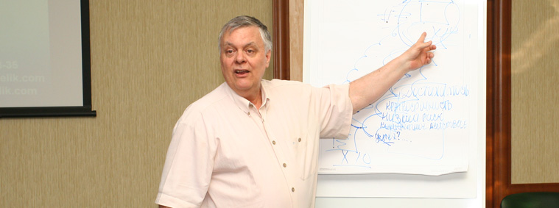

Studying the work of first-class companies in competitive market, we found out that their personnel did not come from Mars; they don’t use magic sticks. They just make the smallest details of business properly.

The way these companies conduct their meetings, how they work with any information, how they prepare action-plans – these are true secrets of their success.

Frank Pucelik,
President of Pucelik Consulting Group

What is this training about?
About the essence of business and details that make great companies great. The materials of this training are the result of monitoring progress of the most profitable companies in competitive market for 20 years. Most of them do not make great discoveries every day and their employees are usual people. But what distinguishes them from all others? How do they hold meetings? What types of meetings exist in effective companies? How do they work with information? After all, they simply make all the little things correctly and do not allow mistakes, especially in the critically important questions.

Purpose and objectives of the training:
To explore the full scheme and practical tools of information processing in a company.
To define the notion "quality of information" and increasing its applicability. To get acquainted with structure and rules of effective meetings. Get practical advice on time management, including creating your own schedule, taking into account repeated monthly and weekly goals.

Actuality of the training:
This training will help you explore the most subtle, yet important details of work of high-class competitive companies. You will perfect the skills of information processing by most effective methods; learn how to manage your time and how to prepare for meetings. We shall learn to use time most usefully in meetings, we shall consider questions of preparation to report. You shall learn to define the tasks that you can delegate to subordinates, and leave that ones that require your personal involvement. We will pay special attention to the success of your projects, clearly mark quality criteria, which must comply with the steps in any action-plan for any project.

During the training participants will learn to:

- correspond to format and rules of participation in the 6 main types of meetings in competitive companies
- filter, organize and distribute any information that comes to company from external and internal sources
- follow steps of effective decision-making
- form your own schedule, considering optimal time allocation to complete tasks efficiently and in time
- correspond to requirements of quality criteria for each step of action-plan, as well as create own plans of actions, most results-oriented

Shortly about the trainer
 | Frank Pucelik - President, Chief Consultant on Organizational Development and the leading business-trainer of Pucelik Consulting Group.  World-known business-trainer on the list of Top-100 US business-trainers (according to Organizational Development Institute of USA), one of the three founders of neurolinguistic programming, the author of a number of books on psychology and articles on personnel management, motivation, work with information.  Each year Frank Pucelik trains more than 2 000 middle- and top-managers of the most successful companies in the CIS countries. Permanent speaker at conferences, forums and other educational activities.

